Collection of the information about Preventive Maintenance software

By:

Adrian Tobias

1. Introduction of each Preventive maintenance software
2. CalemEAM

A basic CMMS web application which is available both online on the internet and available through the mobile phones through the App Store and Play Store.

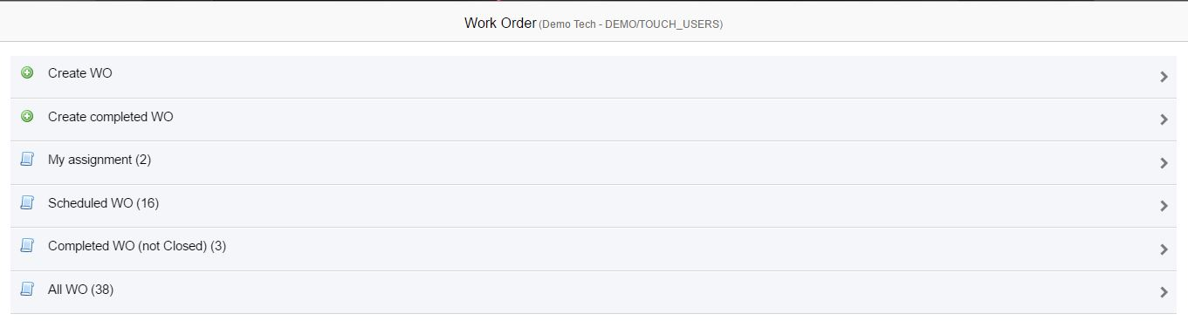

With a simple design for a web application, it offers the creation of WO and a completed WO. With the list of scheduled WO and all the WO created, it provides the user of easy presentation of the WO

1.1 Create WO Form

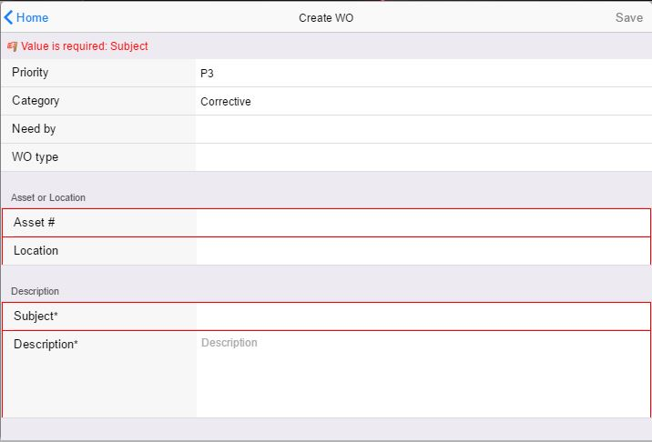

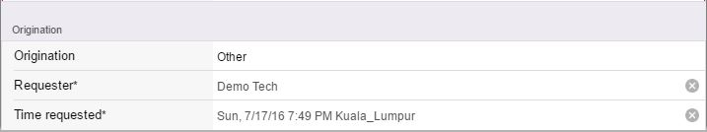

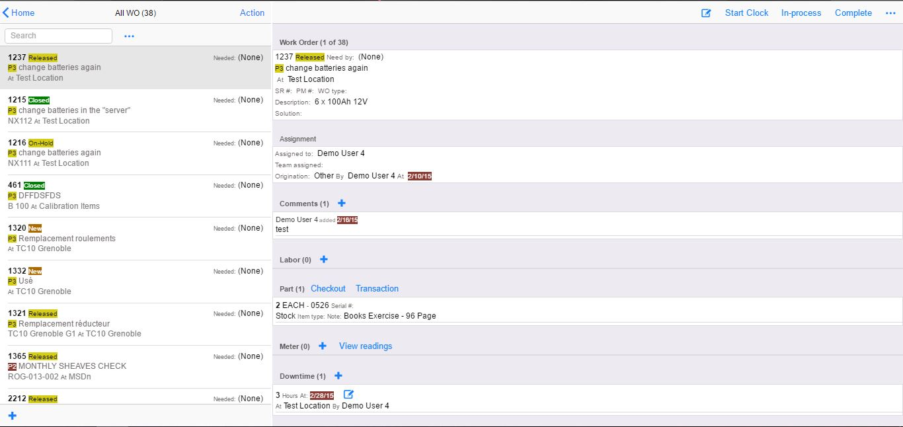1.2 Viewing of the All WO tab containing sample WO

1. Comma CMMS

With a basic dashboard for the users of this CMMS, it completes the necessary needs of every user; a simple design, easy navigation and proper arrangement of the functions.

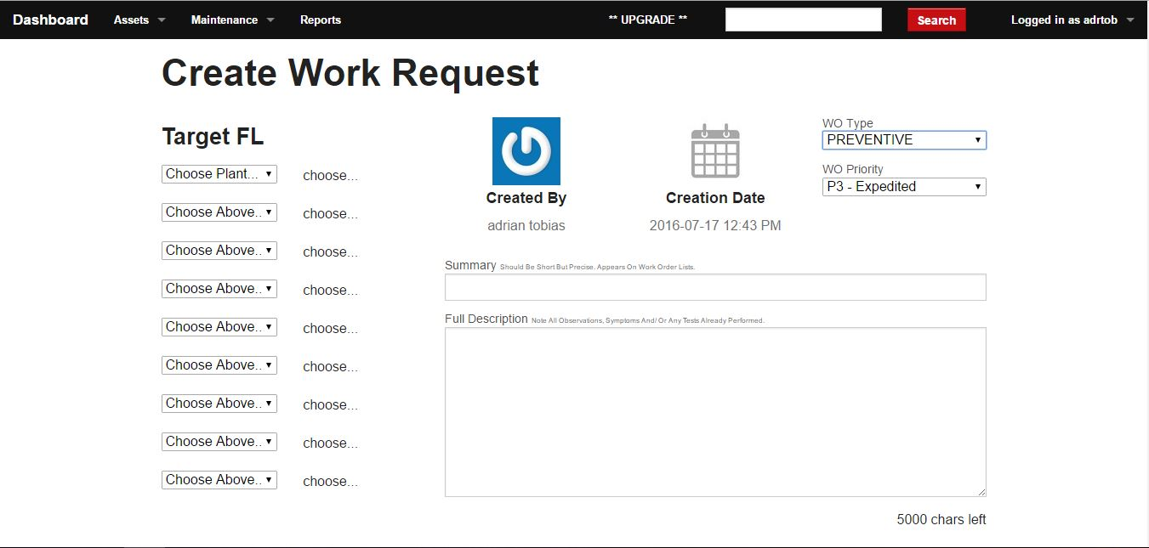

WO type selection is available for a more specific way of sorting out the WO for the company. There is another function where in asset handling is available. The asset tab contains three available categories. One is the Functional Location where in the category gives out the name of the location where a device is, second is the Equipment and Tools for all the equipment in the department and last is the Suppliers where it contains all the information about the suppliers connected to the company.

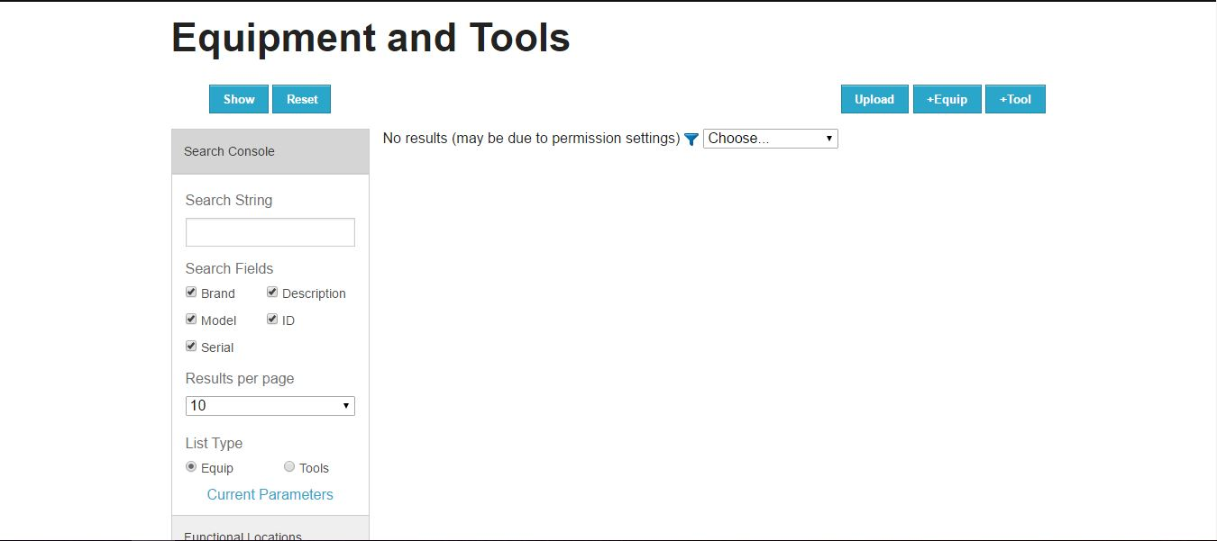2.2 Equipment and Tools Page for Asset Tab

2.3 Maintenance page of the web application

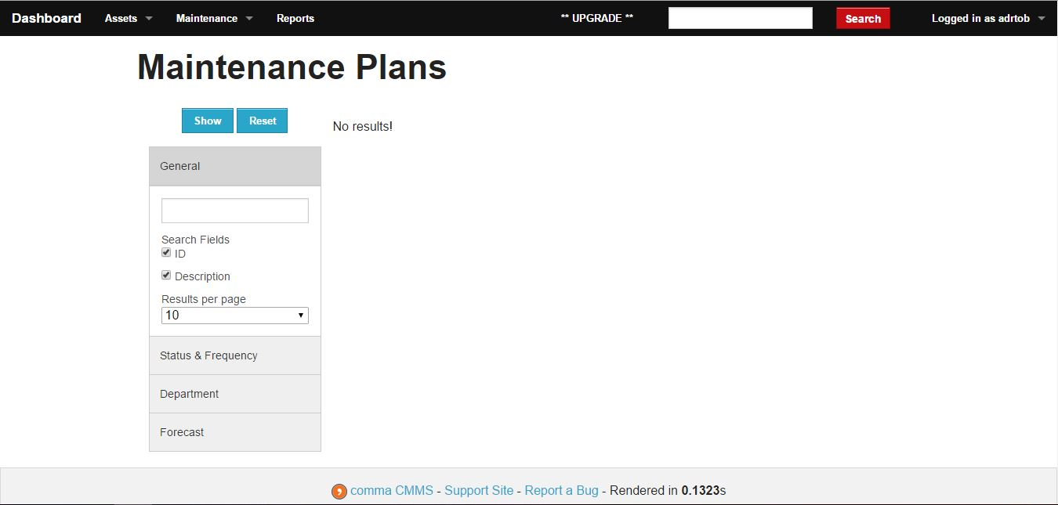

1. Maintenance Assistant – CMMS

A CMMS with an emphasis on its GUI presentation, it holds many features that are important and relevant to preventive maintenance. Available in the computer and on a smartphone, it holds nothing back in terms of mobility. Many users could access some work orders of the company through internet.

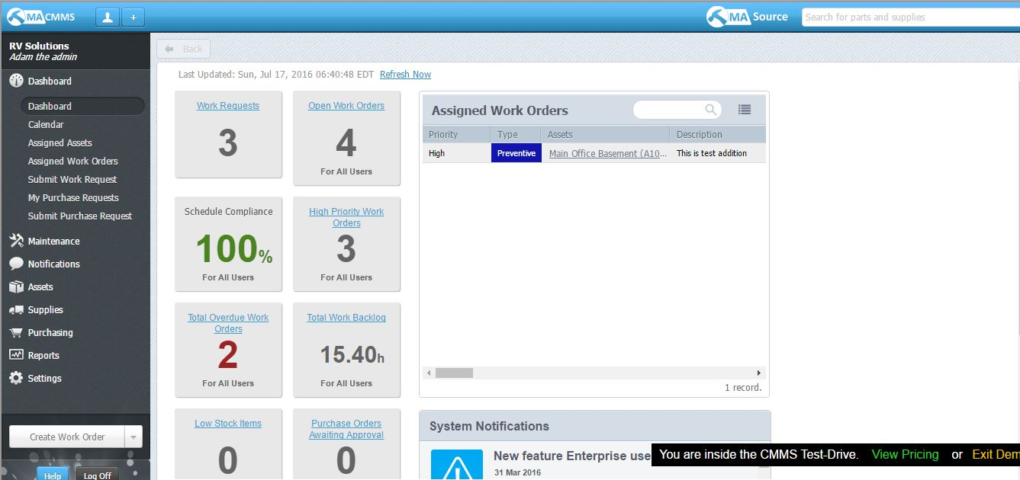3.1 root direction of the Maintenance Assistant website

Presenting all the finished work orders as well as the ongoing work order, all is recorded and presented in a way, the users may view that part first for all the represented data of the work accomplished and ongoing. With the grouping of the functionalities together, it is easier to browse through the tabs on the left side of the web application

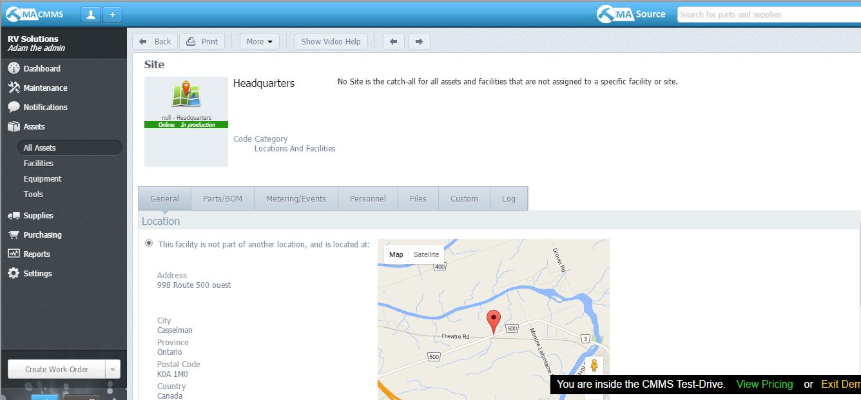3.2 Sample asset information

* 1. Sample Work Order

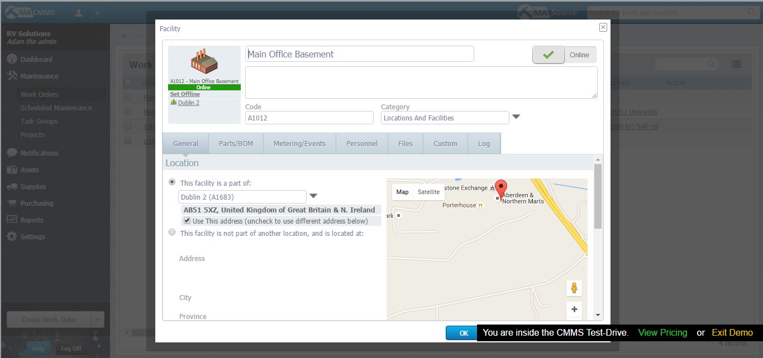

1. openMAINT

With a GUI much like a navigation of SAP and with a basic folder arrangement contain the process according to the folder’s name, it makes the user to see what kinds of process are available. They can also determine quickly where the processes are since it is group together. Also, in this CMMS, they’ve separated the process to other category so that there is no confusion when a user will try the web application.

4.1 openMAINT Main Page

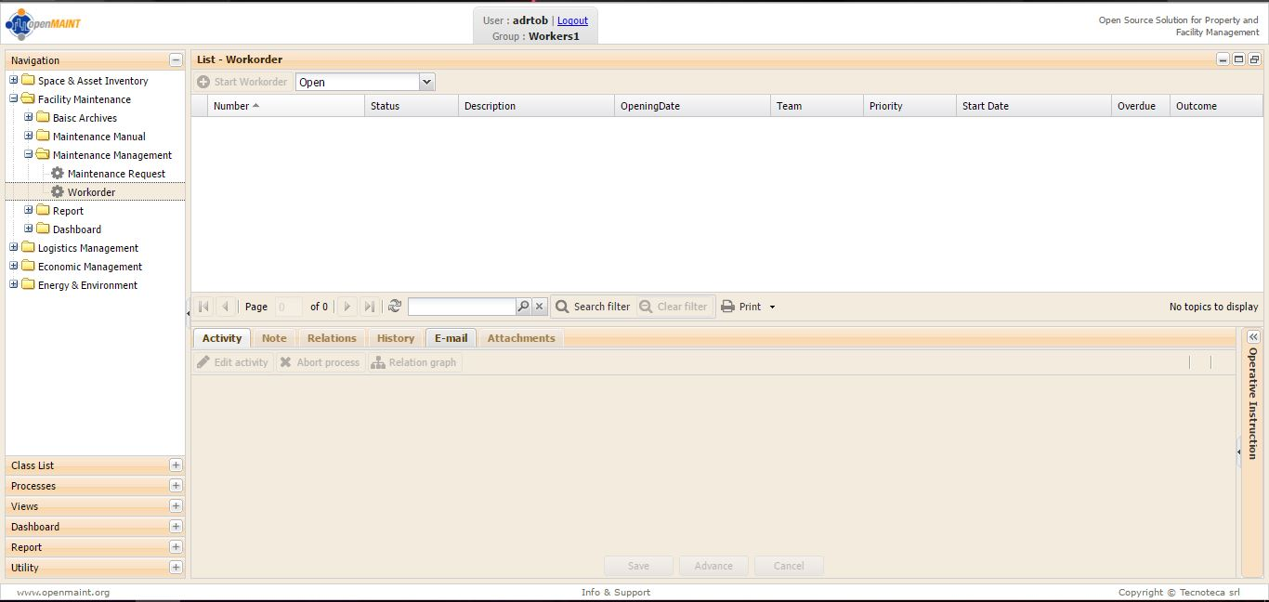

Although it lacks a scheduling process for a maintenance request, it can create maintenance request and reports which could be forwarded to an email address. It could also house an archive section where in work orders which are done and accomplished are stored as archived file. An attachment option is given if there is a need of a document to be accompanied to the record.

4.2 Maintenance Request Form

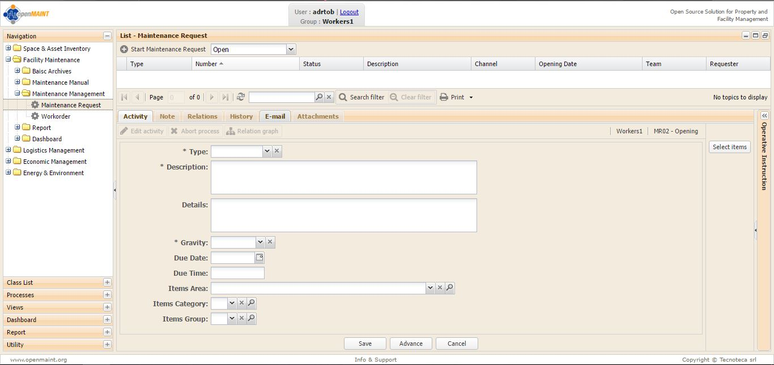

* 1. Basic Archive Page

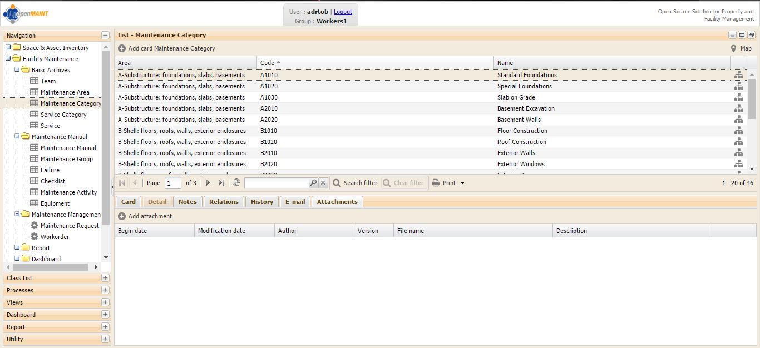

1. SS – CMMS

With a simple look for its front page, it presents a lot of features for a preventive maintenance software. Just like the earlier software, it has work order creation capabilities because that is the common function of any preventive maintenance software. Presenting a statistic charts at the front of the dash page, it shows all the work order separated by type, by priority, by budget and by Equipment.

5.1 Dashboard page of SS - CMMS

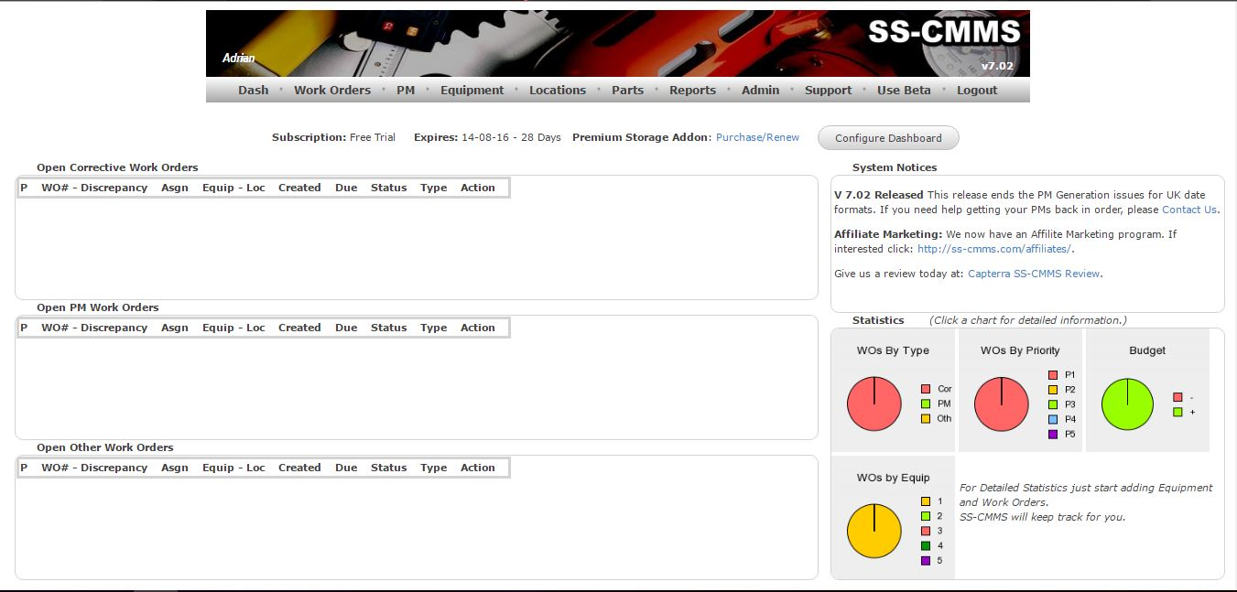

With a scheduling function which creates schedules for maintenance and lets you view the scheduled maintenance through the use of a calendar. A calendar is appropriate for this CMMS since it is easier to see and it’s easier to determine the dates for the maintenance. Another process notable in this online preventive maintenance application is that it has a parts tab which offers to create a record of a specific part. It also offers a view page for searching the parts that are needed by the employee.

5.2 Calendar in the Scheduling tab

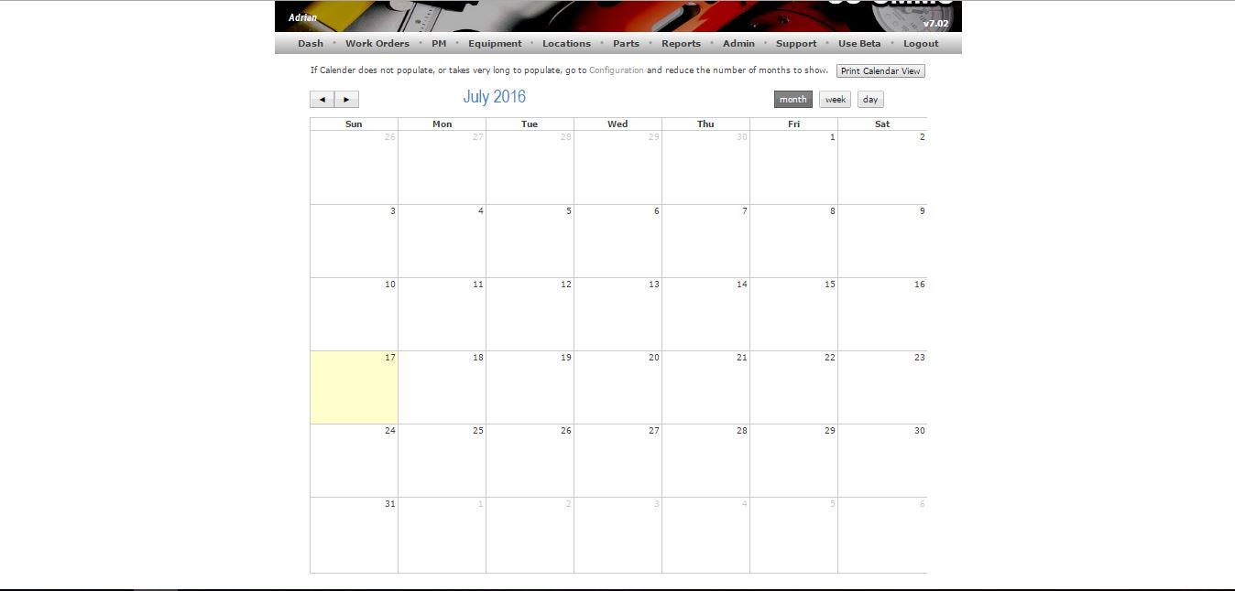

* 1. Parts tab with parts form

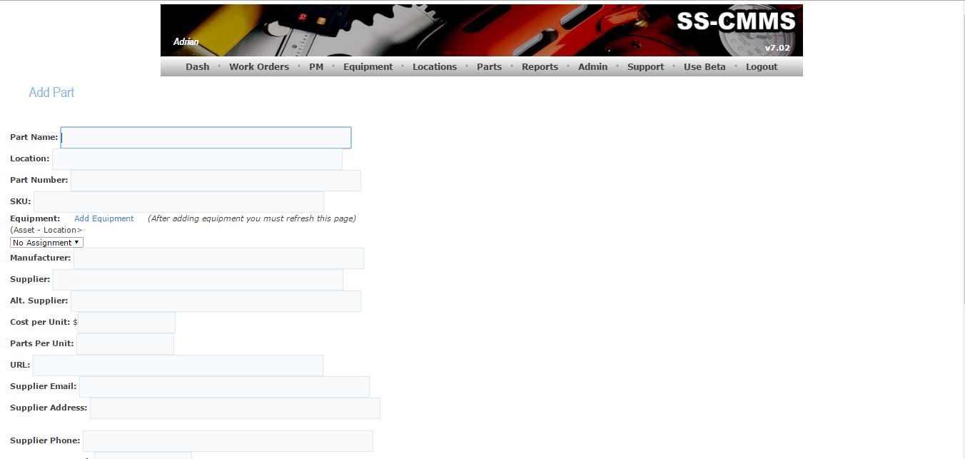

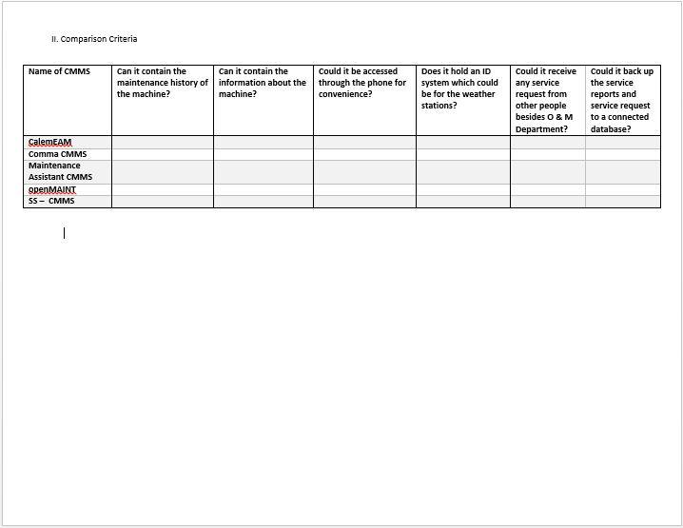

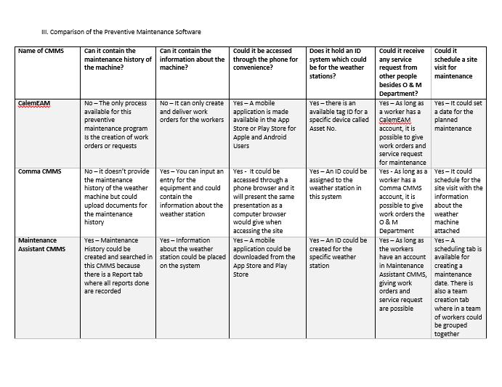

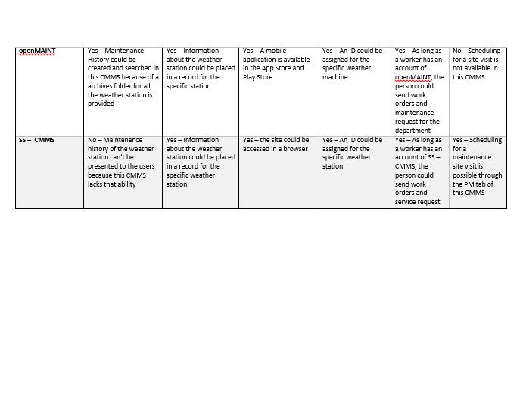

IV. Determining the design from each of the software elaborated

1. Calendar and planning system from SS – CMMS

This GUI presentation of the planned maintenance is what the proposed system needs since it caters to the scheduling process of the new system. This could be shown to the user in an easier way so that there is no confusion in the dates.

1. Asset Information process of Maintenance Assistant CMMS

This process defines all the asset of the system. This part will go perfectly with the Weather Station because in the Asset Information process of MA CMMS, it shows the specific location of the asset via Google Maps. Other than that, it has fields to specify what model it has, the ID and the serial number of the machine for identification purposes.

1. Statistics page of Maintenance Assistant CMMS

This page contains the statistics of the reports and request that are going in and out in the system. This page calculated and warns the users if there are any remaining tasks and maintenance to do and what are the priority tasks that are needed to be done quickly and early as possible. This could be a tool to present the users quick information that are supposed to be known so that work flow will proceed much faster.